**U18CO018**

**Shubham Shekhaliya**

1->

#include <bits/stdc++.h>

using namespace std;

int main() {

    cout << "Enter the number of model in tables: \n";

    map<string, pair<int, int> > mp;

    int n;

    cin >> n;

    while (n--) {

        string name;

        cout << "Enter the model name: ";

        cin >> name;

        int total_unit, cost;

        cout << "Enter the total number of units sold: ";

        cin >> total_unit;

        cout << "Enter the cost of model: ";

        cin >> cost;

        mp[name] = {total_unit, cost};

    }

    while (true) {

        cout << "1 Enter a model name\n2 Exit\n";

        int choice;

        cin >> choice;

        if (choice == 1) {

            cout << "Enter model name: ";

            string name;

            cin >> name;

            if (mp.find(name) == mp.end()) {

                cout << "Model not found !!\n";

            } else {

                pair<int, int> p = mp[name];

                cout << "total units sold: " << p.first << endl;

                cout << "cost of model: " << p.second << endl;

                cout << "total cost: " << p.first * p.second << endl;

            }

        } else {

            break;

        }

    }

    return 0;

}

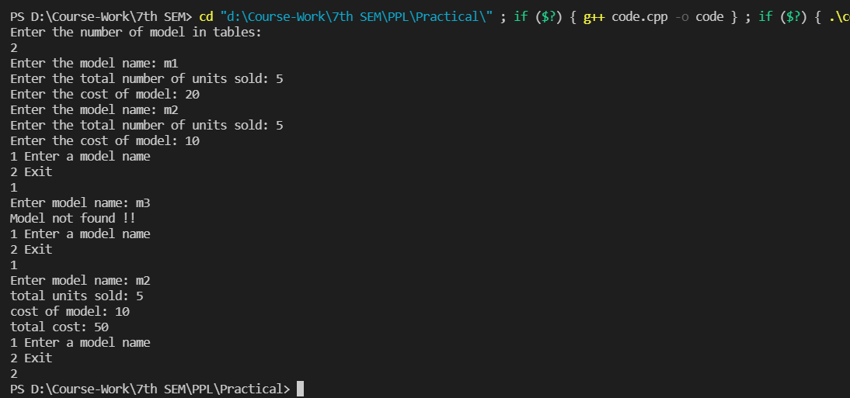

**2->**

patient(p21, shubham, address(shlimar_park, delhi, 395001), [sub(d1, flu), sub(d2,commoncold)] ).

patient(p22, darshan, address(jbnagar, delhi, 395004), [sub(d2, commoncold), sub(d3,chickenpox)] ).

patient(p23, sagar, address(svnit, surat, 395007), [sub(d1, chickenpox), sub(d4,measles)] ).

% flattens list of lists into lists

flatten([],[]).

flatten([H|T],W):-flatten(T,W1), append(W1,H,W).

% remove duplicates from List1 and form List2

remove_duplicates([],[]).

remove_duplicates([H|T], [H|T2]):- not(member(H,T)), remove_duplicates(T,T2).

remove_duplicates([H|T], L2):- member(H,T), remove_duplicates(T,L2).

%q1

total_diseases:-patient(_,X,_,Y), length(Y,L), write(X), write(": "), write(L).

%q2

name_and_zip:-patient(_,X,address(_,_,Zip),_),write(X), write(" has zip code: "), write(Zip).

%q3

citydelhi:- patient(PID,Name,address(_,delhi, _),_), write(PID), write(" has a name "), write(Name), nl.

%q4

contains_doc1([]):-fail.

contains_doc1([treatment(d1,_)|_]):-!.

contains_doc1([_|T]):-contains_doc1(T).

patients_doc1:-patient(_,Name,_,X), contains_doc1(X), write(Name), nl.

%q5

contains_cold([]):-fail.

contains_cold([sub(_,commoncold)|_]):-!.

contains_cold([_|T]):-contains_cold(T).

common_cold_patient:- patient(id,_,_,X), contains_cold(X), write(id), nl.

%q6

cityaddress:- patient(_,_,address(Building, _, Code),_), write("("), write(Building),

write(", "), write(Code), write(")"), nl.

%q7

extract_doctor([],[]).

extract_doctor([treatment(T,_)|Rest], [T|Tail]):-extract_doctor(Rest,Tail).

doctor_for_patients:- patient(_,Name,_,Y),extract_doctor(Y,Z), write(Name), write(": "), write(Z), nl.

